Hello Toast Enhancement Android app with two buttons and a text view. The app allows you to display toast messages and navigate to another activity while also keeping track of a count that you can increase by clicking a button. Let's break it down step by step:

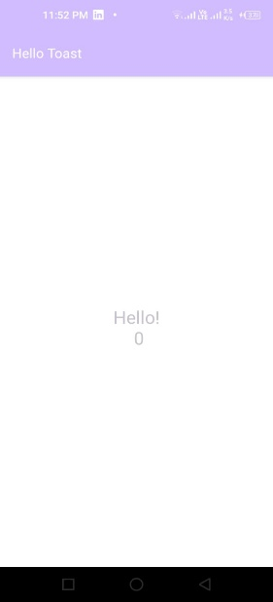

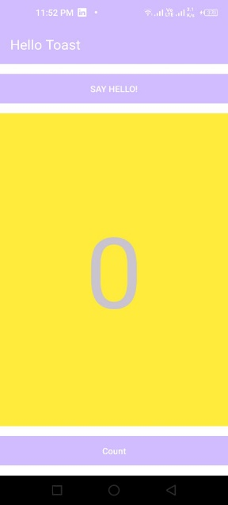

1. **Package and Imports**: The code starts by specifying the package name and importing necessary classes from Android libraries.

package com.example.hellotoast;

import androidx.appcompat.app.AppCompatActivity;

import android.content.Intent;

import android.os.Bundle;

import android.view.View;

import android.widget.TextView;

import android.widget.Toast;

1. **MainActivity Class**: This is the main activity of the Android app, defined by extending `AppCompatActivity`.

public class MainActivity extends AppCompatActivity {

3. **Instance Variable**: Within the `MainActivity` class, there's a private integer variable `mCount` initialized to 0. This variable will be used to keep track of a count.

private int mCount = 0;

4. **onCreate() Method**: This method is part of the Android Activity lifecycle and is called when the activity is created. In this method, the layout for the activity is set.

@Override

protected void onCreate(Bundle savedInstanceState) {

super.onCreate(savedInstanceState);

setContentView(R.layout.activity_main); }

5. **showToast() Method:** This method is called when a button (presumably in the layout) with an `onClick` attribute set to `showToast` is clicked. It displays a short toast message "Hello Toast!".

public void showToast(View view) {

Toast.makeText(this, "Hello Toast!", Toast.LENGTH_SHORT).show();

// Create an intent to start another activity called HelloActivity

Intent intent = new Intent(this, HelloActivity.class)

// Pass the current count as an extra to the intent

intent.putExtra("count", mCount);

// Start the HelloActivity

startActivity(intent);

}

6. **countUp() Method**: This method is called when a button (presumably in the layout) with an `onClick` attribute set to `countUp` is clicked. It increments the `mCount` variable and updates the text displayed in a `TextView` with the new count.

public void countUp(View view) {

mCount++;

TextView countTextView = findViewById(R.id.show_count);

countTextView.setText(Integer.toString(mCount));

}

That's the overview of the code. In summary, it's a simple Android app with two buttons—one to display a toast message and another to increment a count. When the toast button is clicked, it also starts another activity called `HelloActivity` and passes the current count as an extra to that activity. The count is displayed in a `TextView` on the screen.